Villasmil-Ω Coherence Index: A Quantitative Framework for Analyzing and Optimizing Complex Systems

Author:
Ilver Villasmil
Miami, Florida, USA
ilvervillasmil@gmail.com

Abstract

The Villasmil-Ω formula is presented as a coherence index (Ch) for measuring stability and coherence in complex systems under external perturbations. The model integrates weighted modules representing different system aspects (economic, social, physical, technological, personal), together with action factors and external interference. The formula identifies critical modules, calculates overall coherence, and evaluates the effectiveness of strategic interventions. This framework is applicable to social, economic, technological, physical, and personal systems, serving as a diagnostic, predictive, and planning tool.

Introduction

Complex systems require metrics that integrate multiple dimensions quantitatively. The Villasmil-Ω formula was developed to assess global coherence in systems where interdependent modules may collapse due to external noise, internal pressure, or weak critical modules. The Ch index provides a universal framework for measuring stability and predicting vulnerabilities, applicable to social structures, physical systems, or technological networks.

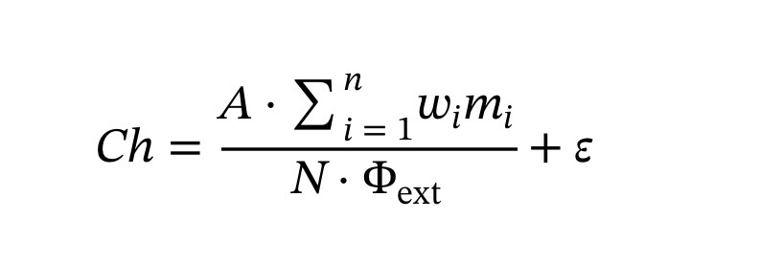
Villasmil-Ω Formula
\begin{equation} Ch = \frac{A \cdot \sum_{i=1}^{n} w_i m_i}{N \cdot \Phi_{\mathrm{ext}}} + \varepsilon \end{equation}

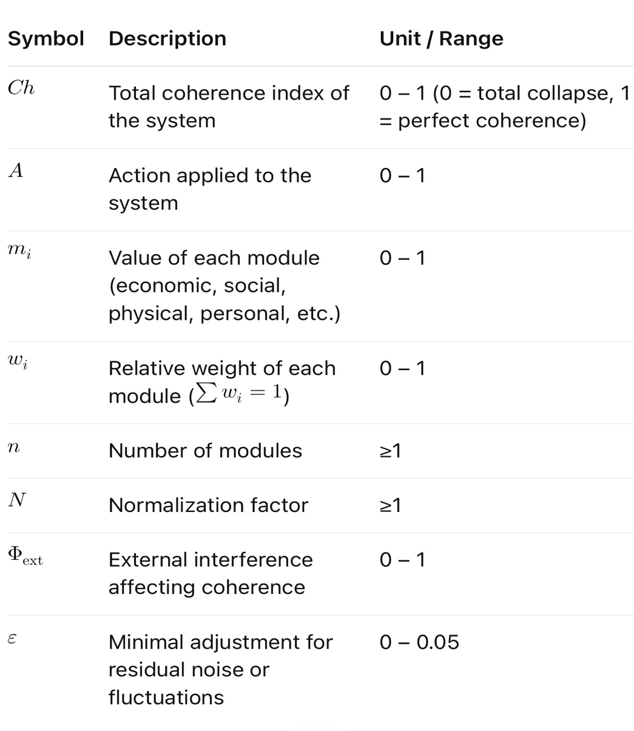
Variable Definitions

Variable Definitions
Symbol | Description | Unit / Range
Ch | Total coherence index of the system | 0 – 1 (0 = total collapse, 1 = perfect coherence)
A | Action applied to the system | 0 – 1
m_i | Value of each module (economic, social, physical, personal, etc.) | 0 – 1
w_i | Relative weight of each module (\sum w_i = 1) | 0 – 1
n | Number of modules | ≥1
N | Normalization factor | ≥1
\Phi_{\mathrm{ext}} | External interference affecting coherence | 0 – 1
\varepsilon | Minimal adjustment for residual noise or fluctuations | 0 – 0.05

Conceptual Application: Global Power 2026

Modules and weights:
Module | Value m_i | Weight w_i
Economic | 0.85 | 0.3
Political | 0.70 | 0.25
Social | 0.60 | 0.2
Energy | 0.75 | 0.15
Technological | 0.90 | 0.1
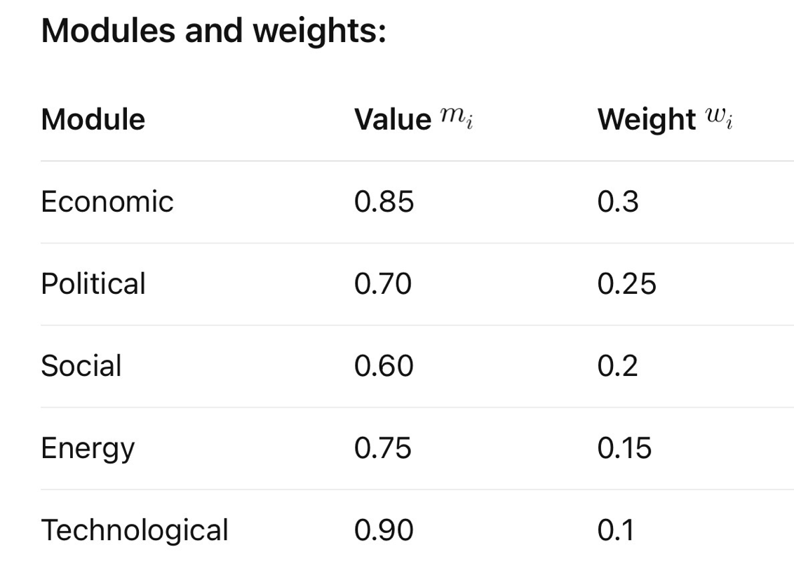
External parameters:
- Action A = 0.88
- Normalization N = 1
- External interference \Phi_{\mathrm{ext}} = 0.95
- Adjustment \varepsilon = 0.037

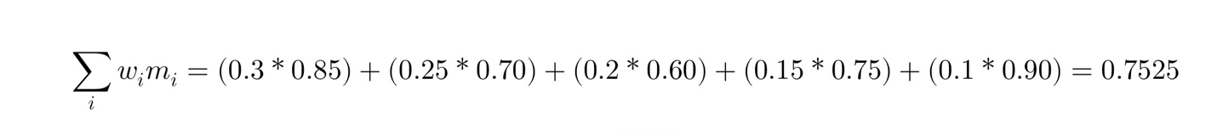
Weighted sum of modules:

\sum_i w_i m_i = (0.3*0.85) + (0.25*0.70) + (0.2*0.60) + (0.15*0.75) + (0.1*0.90) = 0.7525

Ch calculation:

Ch = \frac{0.88 * 0.7525}{1 * 0.95} + 0.037 = 0.733
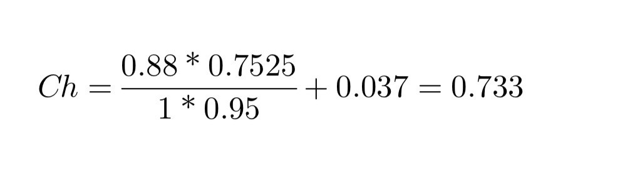
Interpretation:
- Ch = 0.733 → partial coherence
- Critical modules: Social (0.60) and Political (0.70)
- Strategic action (A) and reducing external interference (\Phi_{\mathrm{ext}}) can increase coherence.

Discussion
- The Villasmil-Ω formula allows diagnosing vulnerabilities and planning strategic interventions.
- Each module can be measured objectively or using validated proxies.
- The Ch index serves as a single metric to compare complex system states and evaluate the effectiveness of policies, interventions, or technological changes.

Conclusion

The Villasmil-Ω formula provides a robust quantitative framework for measuring coherence in complex systems, integrating weighted modules, applied action, and external noise. Its conceptual application to Global Power 2026 demonstrates its usefulness in identifying critical points and guiding improvement strategies. This model is scalable and adaptable to other high-complexity systems, including physical, social, and personal domains.

Contact:
Ilver Villasmil
Miami, Florida, USA
ilvervillasmil@gmail.com

